***Practical-01***

**Aim:** Study and implementation of Infrastructure as a Service. Study of Cloud Computing & Architecture.

**Objective:** From this experiment, the student will be able to

. provide an overview of concepts of Cloud Computing . •

. To encourage students to indulge into research in Cloud Computing.

**Outcome:** The learner will be able to •

. understand and appreciate cloud architecture. •

. analyze the local and global impact of computing on individuals, organizations, and society. •

. recognize the need for, and an ability to engage in life-long learning.

**Hardware/Software Requirement:** Ubuntu operating system, Internet.

**Theory:** Cloud computing enables companies to consume compute resources as a utility -- just like electricity -- rather than having to build and maintain computing infrastructures in-house. Cloud computing promises several attractive benefits for businesses and end users. Three of the main benefits of cloud computing include: • Self-service provisioning: End users can spin up computing resources for almost any type of workload on-demand. • Elasticity: Companies can scale up as computing needs increase and then scale down again as demands decreases. Pay per use: Computing resources are measured at a granular level, allowing users to pay only for the resources and workloads they use. Cloud computing services can be Private, Public or Hybrid. Private cloud services are delivered from a business' data center to internal users. This model offers versatility and convenience, while preserving management, control and security. Internal customers may or may not be billed for services through IT chargeback. In the Public cloud model, a third-party provider delivers the cloud service over the Internet. Public cloud services are sold on-demand, typically by the minute or the hour. Customers only pay for the CPU cycles, storage or bandwidth they consume. Leading public cloud providers include Amazon Web Services (AWS), Microsoft Azure, IBM/SoftLayer and Google Compute Engine. Hybrid cloud is a combination of public cloud services and on-premises private cloud – with orchestration and automation between the two. Companies can run mission-critical workloads or sensitive applications on the private cloud while using the public cloud for workloads that must scale on-demand. The goal of hybrid cloud is to create a unified, automated, scalable environment which takes advantage of all that a public cloud infrastructure can provide, while still maintaining control over mission-critical data. Types of cloud computing: IT people talk about three different kinds of cloud computing, where different services are being provided for you. Note that there's a certain amount of vagueness about how these things are defined and some overlap between them. • Infrastructure as a Service (IaaS) means you're buying access to raw computing hardware over the Net, such as servers or storage. Since you buy what you need and pay-as-you-go, this is often referred to as utility computing. Ordinary web hosting is a simple example of IaaS: you pay a monthly subscription or a per-megabyte/gigabyte fee to have a hosting company serve up files for your website from their servers. • Software as a Service (SaaS) means you use a complete application running on someone else's system. Web-based email and Google Documents are perhaps the best-known examples. Zoho is another well-known SaaS provider offering a variety of office applications online. • Platform as a Service (PaaS) means you develop applications using Webbased tools so they run on systems software and hardware provided by another company. So, for example, you might develop your own ecommerce website but have the whole thing, including the shopping cart, checkout, and payment mechanism running on a merchant's server. Force.com (from salesforce.com) and the Google App Engine are examples of PaaS. • Advantages and disadvantages of cloud computing Advantages: The pros of cloud computing are obvious and compelling. If your business is selling books or repairing shoes, why get involved in the nitty gritty of buying and maintaining a complex computer system? If you run an insurance office, do you really want your sales agents wasting time running anti-virus software, upgrading word-processors, or worrying about hard-drive crashes? Do you really want them cluttering your expensive computers with their personal emails, illegally shared MP3 files, and naughty YouTube videos—when you could leave that responsibility to someone else? Cloud computing allows you to buy in only the services you want, when you want them, cutting the upfront capital costs of computers and peripherals. You avoid equipment going out of date and other familiar IT problems like ensuring system security and reliability. You can add extra services (or take them away) at a moment's notice as your business needs change. It's really quick and easy to add new applications or services to your business without waiting weeks or months for the new computer (and its software) to arrive. Disadvantages: Instant convenience comes at a price. Instead of purchasing computers and software, cloud computing means you buy services, so one-off, upfront capital costs become ongoing operating costs instead. That might work out much more expensive in the long-term. If you're using software as a service (for example, writing a report using an online word processor or sending emails through webmail), you need a reliable, highspeed, broadband Internet connection functioning the whole time you're working. That's something we take for granted in countries such as the United States, but it's much more of an issue in developing countries or rural areas where broadband is unavailable. If you're buying in services, you can buy only what people are providing, so you may be restricted to off-the-peg solutions rather than ones that precisely meet your needs. Not only that, but you're completely at the mercy of your suppliers if they suddenly decide to stop supporting a product you've come to depend on. (Google, for example, upset many users when it announced in September 2012 that its cloud-based Google Docs would drop support for old but de facto standard Microsoft Office file formats such as .DOC, .XLS, and .PPT, giving a mere one week's notice of the change—although, after public pressure, it later extended the deadline by three months.) Critics charge that cloud-computing is a return to the bad-old days of mainframes and proprietary systems, where businesses are locked into unsuitable, long-term arrangements with big, inflexible companies. Instead of using "generative" systems (ones that can be added to and extended in exciting ways the developers never envisaged), you're effectively using "dumb terminals" whose uses are severely limited by the supplier. Good for convenience and security, perhaps, but what will you lose in flexibility? And is such a restrained approach good for the future of the Internet as a whole? (To see why it may not be, take a look at Jonathan Zittrain's eloquent book The Future of the Internet— And How to Stop It.)

**Conclusion:** Cloud computing enables a convenient and on-demand network access to a wide range of resources. The different services and also the deployment models allow flexible service provider interaction with minimal human intervention. It saves costs but also can lead to risk issues and suspension of resources when in huge quantity.

***Practical-02***

**Aim:** Installation and Configuration of virtualization using KVM.

**Objectives:** From this experiment, the student will be able to,

. Understand the concepts of virtualization. •

. Understand KVM architecture and its configuration.

**Outcomes:** The learner will be able, •

. To analyze user models and develop user centric interfaces •

. To analyze the local and global impact of computing on individuals, organizations, and society. •

. To engage in life-long learning development and higher studies.

. To understand, identify, analyze and design the problem, implement and validate the solution including both hardware and software.

**Hardware/Software Requirement:** Ubuntu operating system, open source software KVM, Internet.

**Theory:** Virtualization is software that separates physical infrastructures to create various dedicated resources. It is the fundamental technology that powers cloud computing. The technology behind virtualization is known as a virtual machine monitor (VMM) or virtual manager, which separates compute environments from the actual physical infrastructure. Virtualization makes servers, workstations, storage and other systems independent of the physical hardware layer. This is done by installing a Hypervisor on top of the hardware layer, where the systems are then installed. There are three areas of IT where virtualization is making headroads, network virtualization, storage virtualization and server virtualization: • Network virtualization is a method of combining the available resources in a network by splitting up the available bandwidth into channels, each of which is independent from the others, and each of which can be assigned (or reassigned) to a particular server or device in real time. The idea is that virtualization disguises the true complexity of the network by separating it into manageable parts, much like your partitioned hard drive makes it easier to manage your files. • Storage virtualization is the pooling of physical storage from multiple network storage devices into what appears to be a single storage device that is managed from a central console. Storage virtualization is commonly used in storage area networks (SANs). • Server virtualization is the masking of server resources (including the number and identity of individual physical servers, processors, and operating systems) from server users. The intention is to spare the user from having to understand and manage complicated details of server resources while increasing resource sharing and utilization and maintaining the capacity to expand later. Virtualization can be viewed as part of an overall trend in enterprise IT that includes autonomic computing, a scenario in which the IT environment will be able to manage itself based on perceived activity, and utility computing, in which computer processing power is seen as a utility that clients can pay for only as needed. The usual goal of virtualization is to centralize administrative tasks while improving scalability and work loads.

**Procedures:** Installation Steps :

1. #sudo grep -c "svm\|vmx" /proc/cpuinfo
2. #sudo apt-get install qemu-kvm libvirt-bin bridge-utils virt- manager
3. #sudoadduserrait
4. #sudoadduserraitlibvirtd After running this command, log out and log back in as rait
5. Run following command after logging back in as rait and you should see an empty list of virtual machines. This indicates that everything is working correctly.
6. #virsh -c qemu:///system list
7. Open Virtual Machine Manager application and Create Virtual Machine
8. #virt-manager

**Results:**

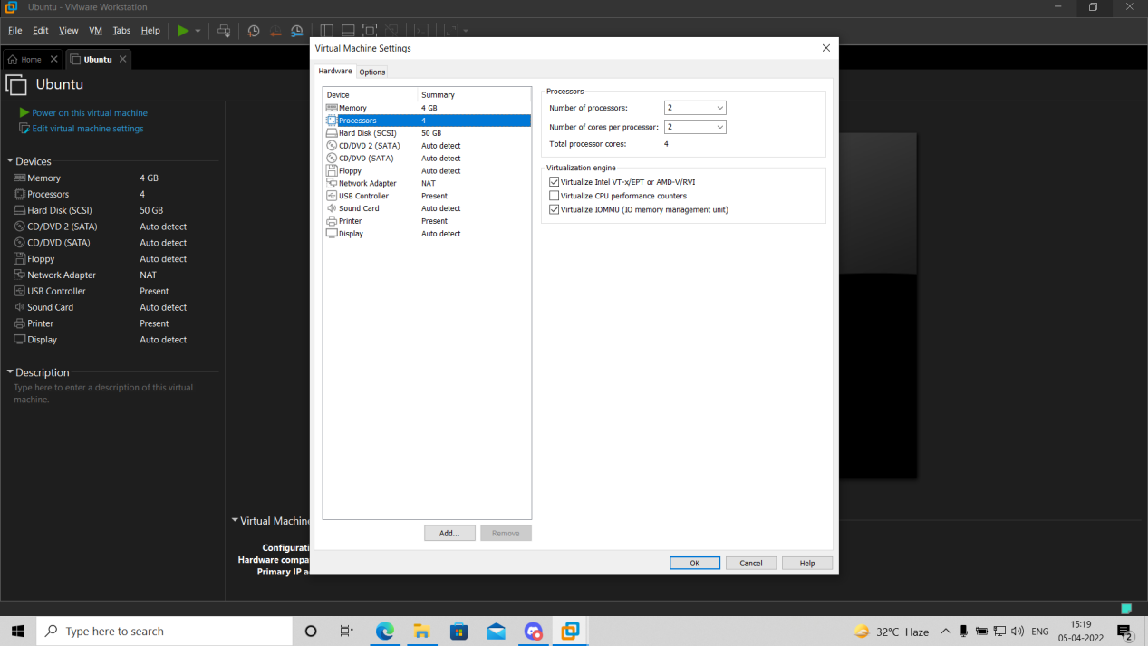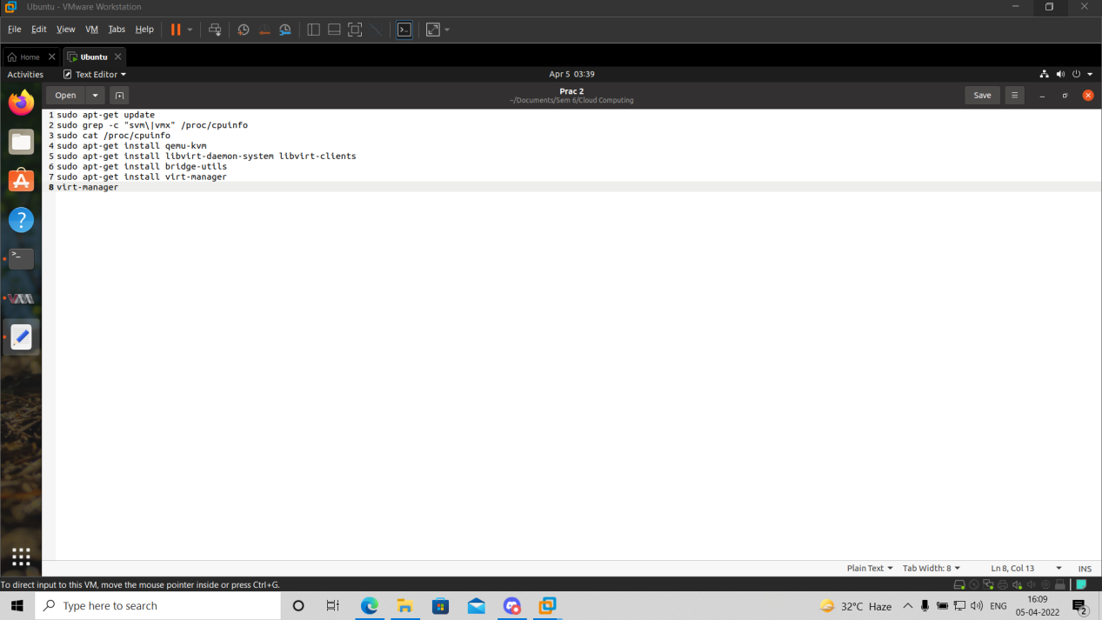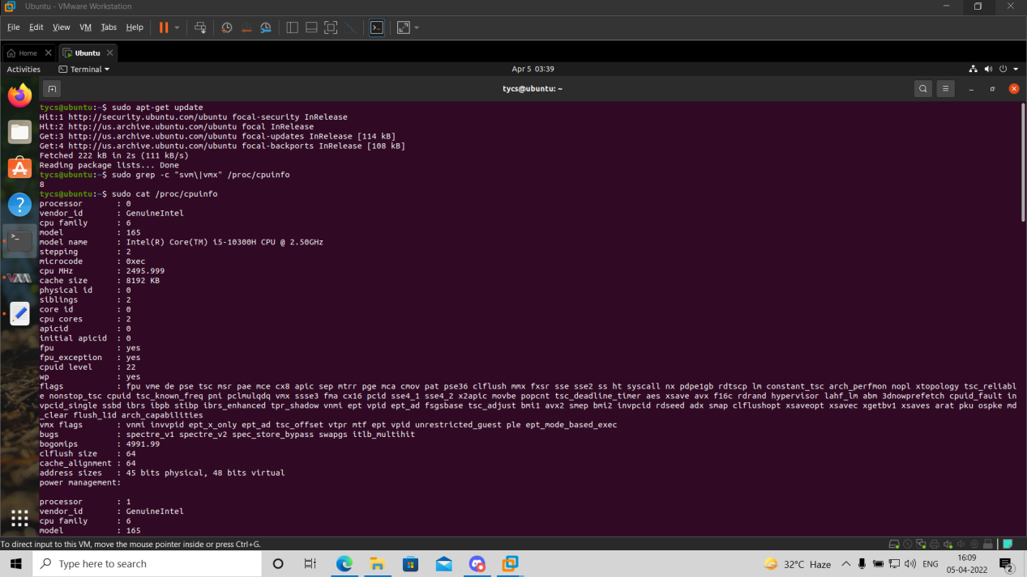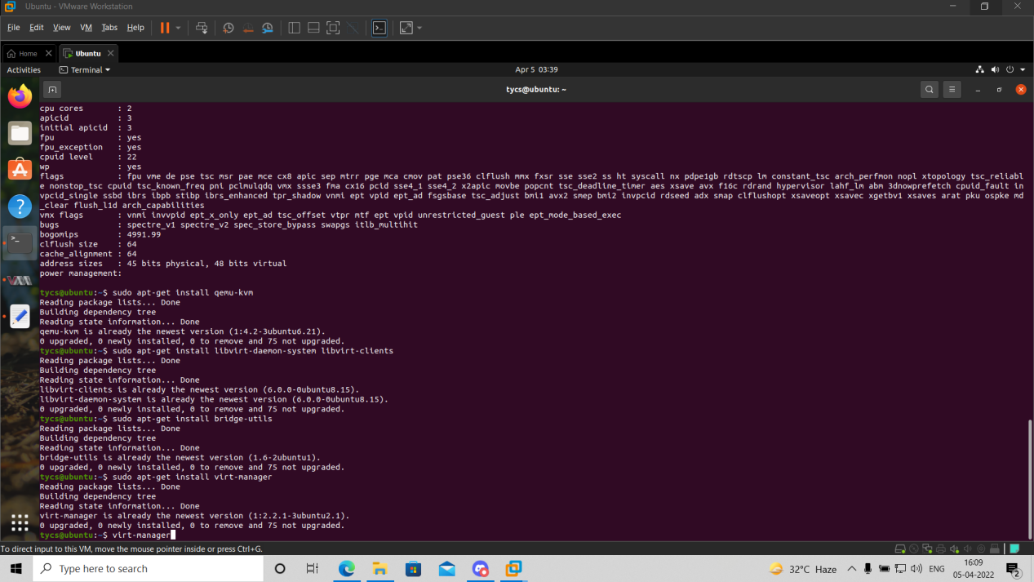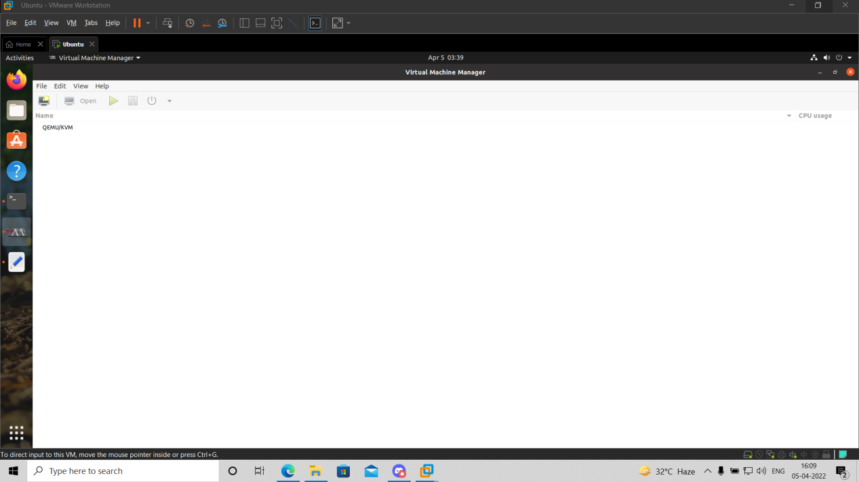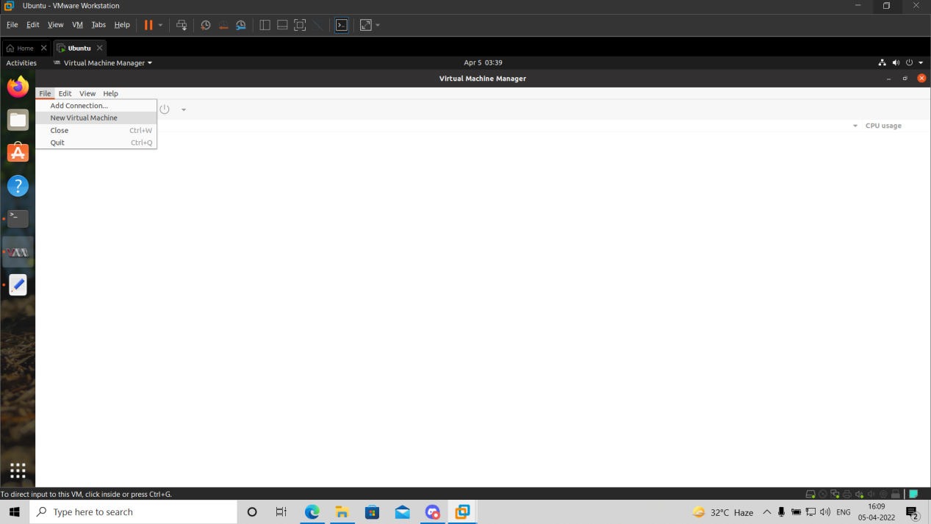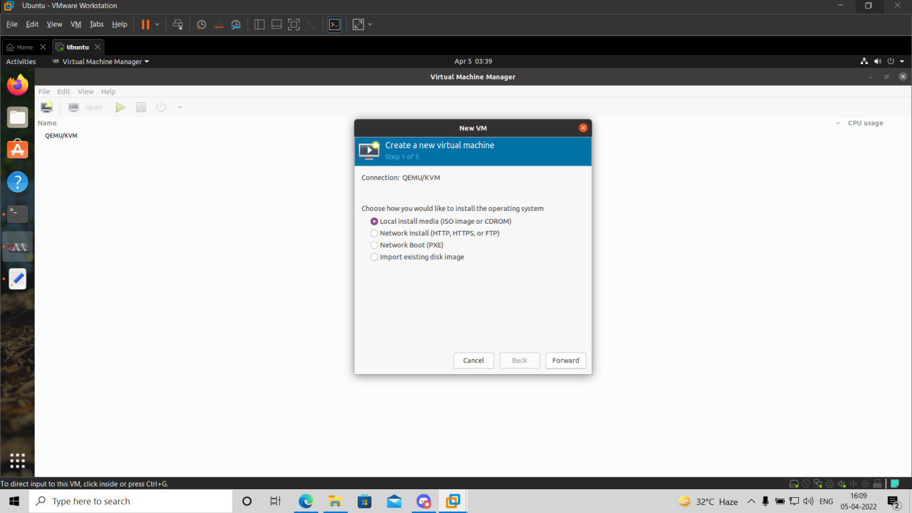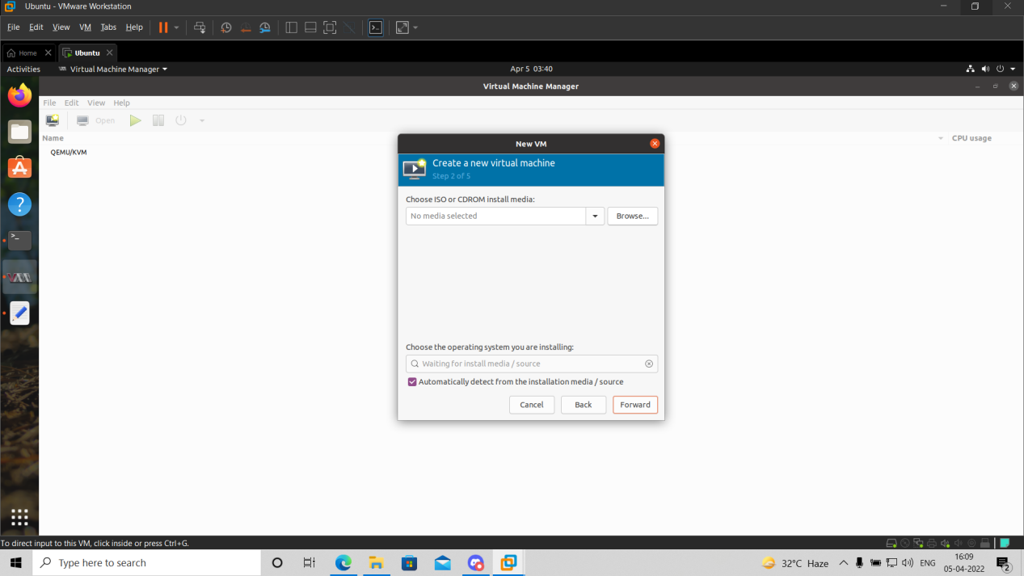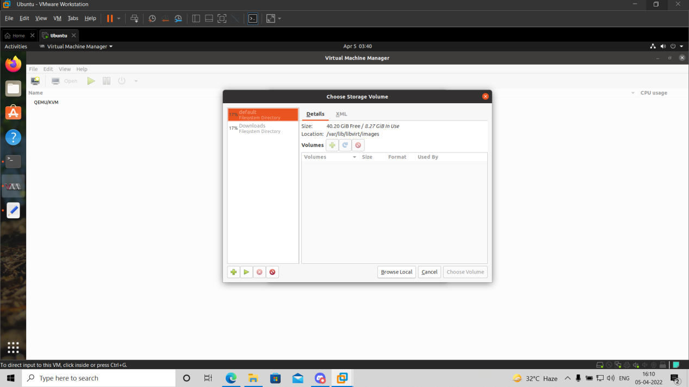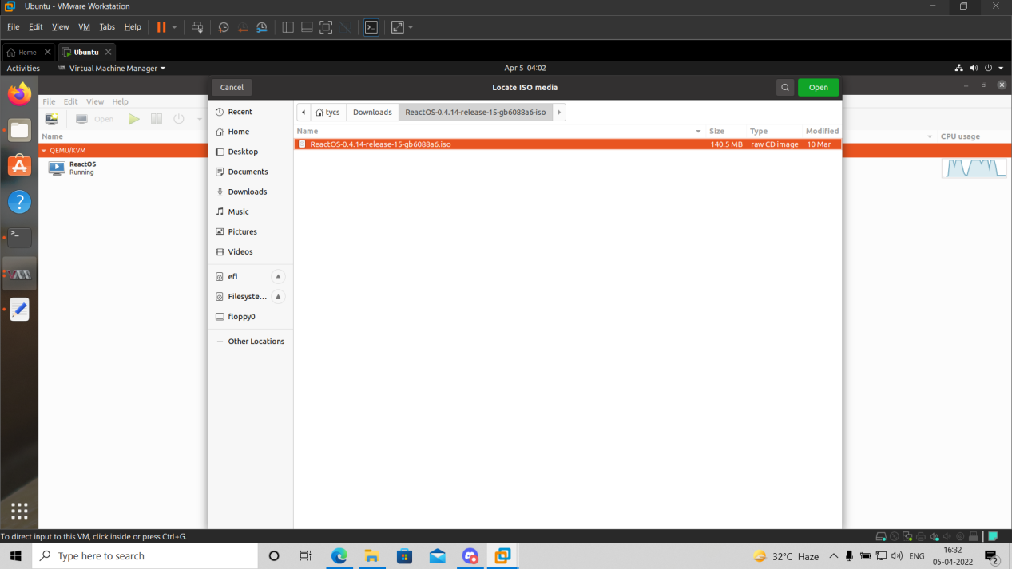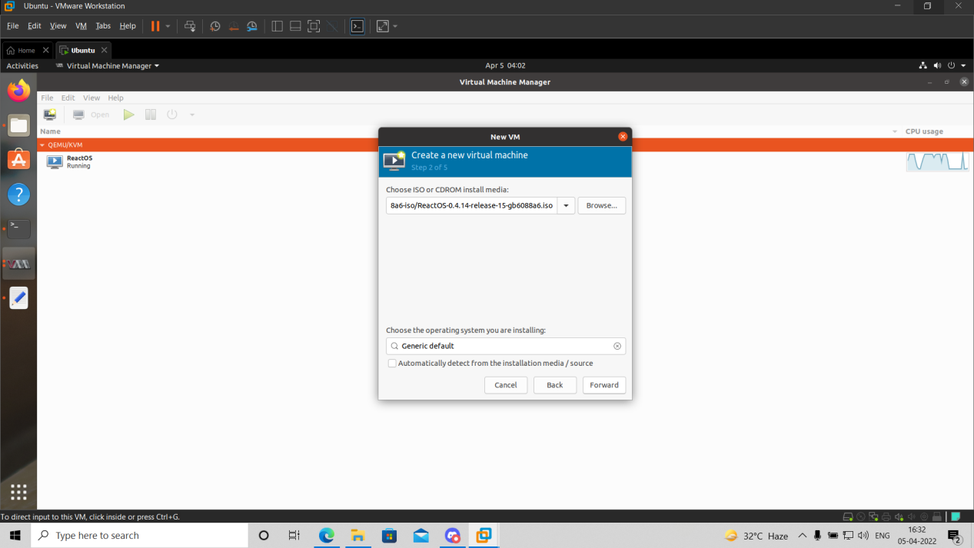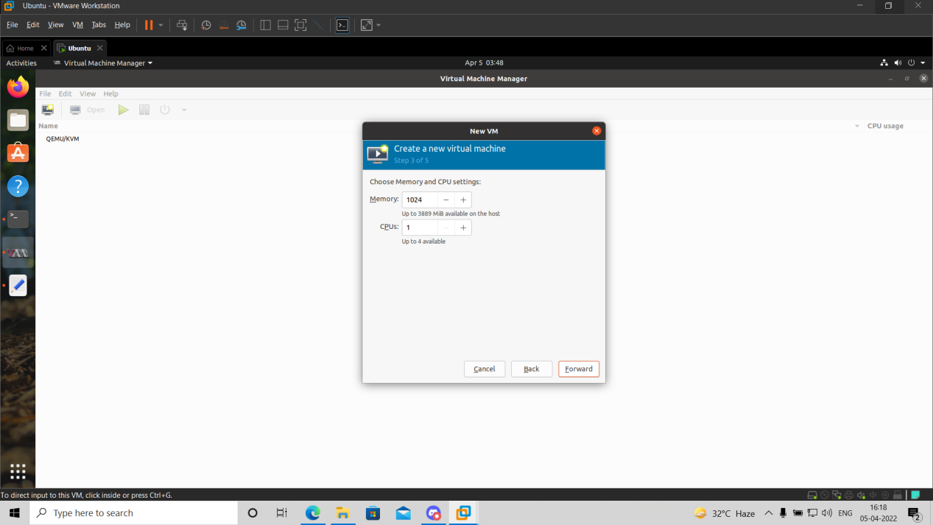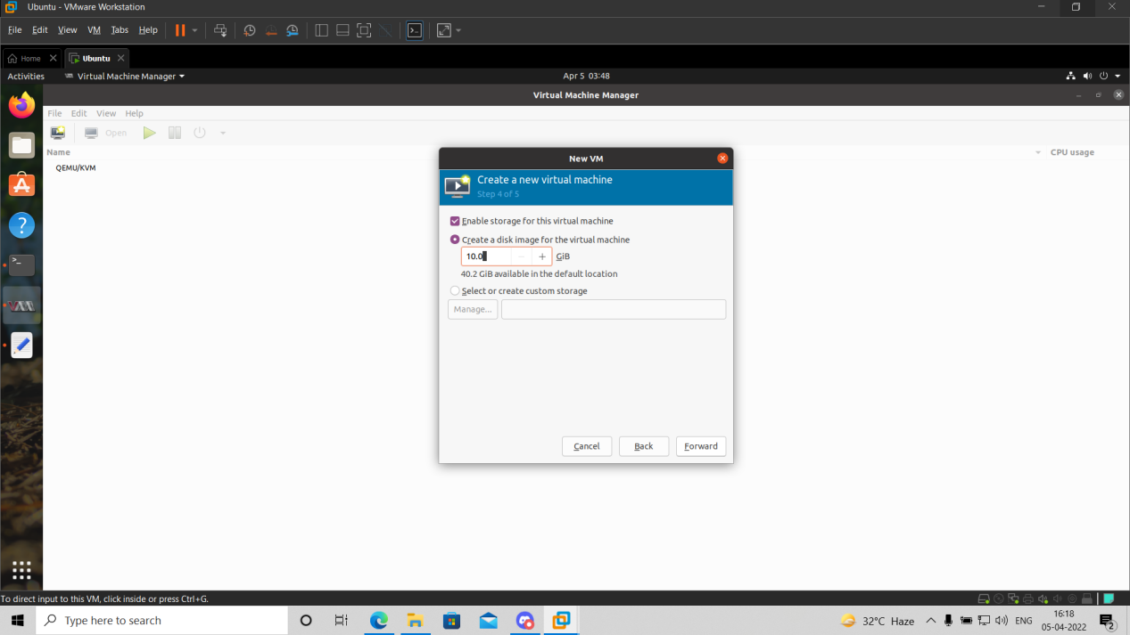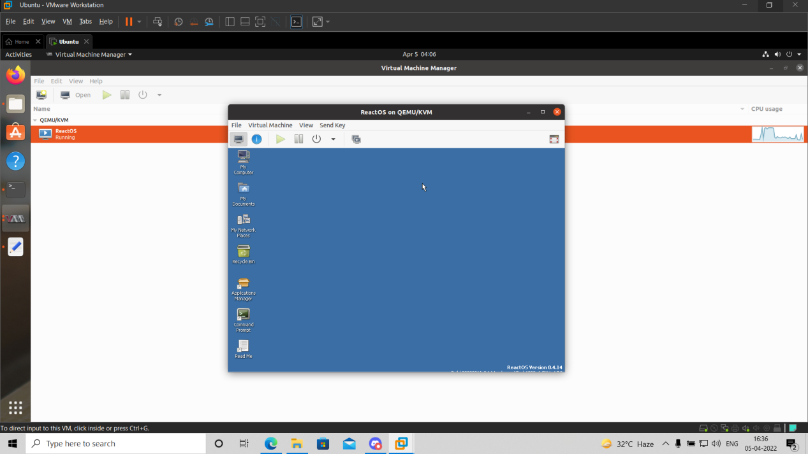

***Practical-03***

**Aim:** Study and implementation of Infrastructure as a Service.

**Objectives:** From this experiment, the student will be able to,

. Understand concepts of virtualization and to use cloud as Infrastructure as a services. •

. Learn the technique and its complexity •

. Understand the importance of this technique from application point of view.

**Outcomes:** The learner will be able, •

. To match the industry requirements in the domains of Database management, Programming and Networking with limited infrastructure.

. To analyze the local and global impact of computing on individuals, organizations, and society. •

. To use current techniques, skills, and tools necessary for computing practice.

**Hardware/Software Requirements:** Ubuntu operating system, Virtual machine, WAMP/ZAMP server, Any tool or technology can be used for implementation of web application e.g., JAVA, PHP, etc.

**Procedures:**

1. Installation Steps: (https://docs.openstack.org/devstack/latest/guides/single-machine.html)
2. Add user useradd -s /bin/bash -d /opt/stack -m stack
3. apt-get install sudo -y
4. echo "stack ALL=(ALL) NOPASSWD: ALL" >> /etc/sudoers
5. login as stack user Download DevStack
6. sudo apt-get install git -y || sudo yum install -y git git clone
7. https://git.openstack.org/openstack-dev/devstack
8. cd devstack
9. Run DevStack
10. Now to configure stack.sh.
11. DevStack includes a sample in devstack/samples/local.conf.
12. Create local.conf as shown below to do the following: •   
    Set FLOATING_RANGE to a range not used on the local network, i.e. 192.168.1.224/27.   
    This configures IP addresses ending in 225-254 to be used as floating IPs. •   
    Set FIXED_RANGE and FIXED_NETWORK_SIZE to configure the internal address space used by the instances. •   
    Set FLAT_INTERFACE to the Ethernet interface that connects the host to your local network.   
    This is the interface that should be configured with the static IP address mentioned above. •   
    Set the administrative password.   
    This password is used for the admin and demo accounts set up as OpenStack users. •   
    Set the MySQL administrative password.   
    The default here is a random hex string which is inconvenient if you need to look at the database directly for anything. • Set the RabbitMQ password. •   
    Set the service password.   
    This is used by the OpenStack services (Nova, Glance, etc) to authenticate with Keystone.
13. **Local.conf should look something like this:**   
    [[local|localrc]]   
    FLOATING_RANGE=192.168.1.224/27   
    FIXED_RANGE=10.11.12.0/24   
    FIXED_NETWORK_SIZE=256   
    FLAT_INTERFACE=eth0   
    ADMIN_PASSWORD=supersecret   
    DATABASE_PASSWORD=iheartdatabases   
    RABBIT_PASSWORD=flopsymopsy
14. Run DevStack:   
    SERVICE_PASSWORD=iheartksl ./stack.sh A seemingly endless stream of activity ensues.
15. When complete you will see a summary of stack.sh’s work, including the relevant URLs, accounts and passwords to poke at your shiny new OpenStack.
16. Using OpenStack At this point you should be able to access the dashboard from other computers on the local network. In this example that would be http://192.168.43.29/ for the dashboard (aka Horizon). Launch VMs and if you give them floating IPs and security group access those VMs will be accessible from other machines on your network.

**Results:**

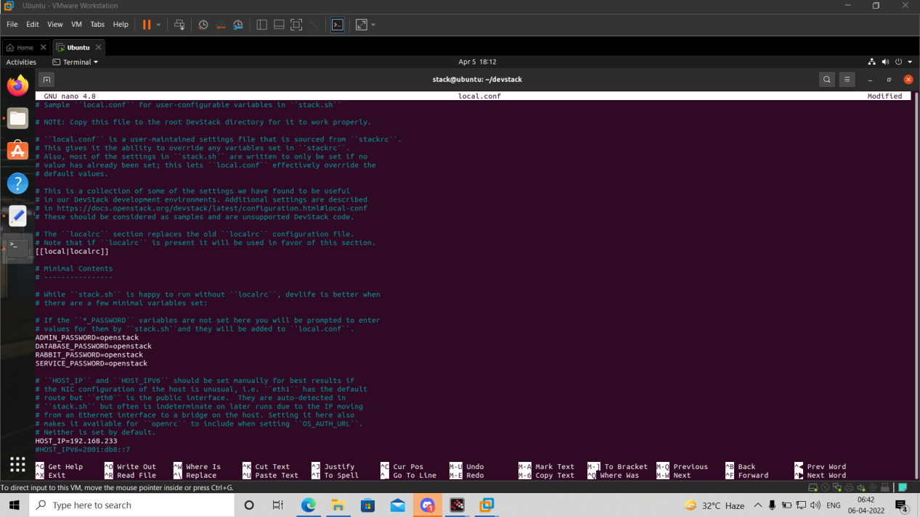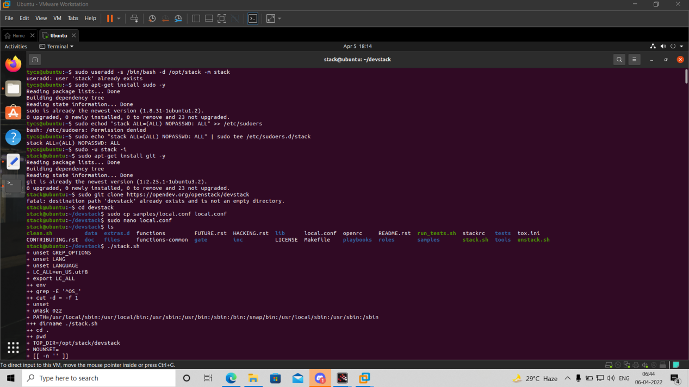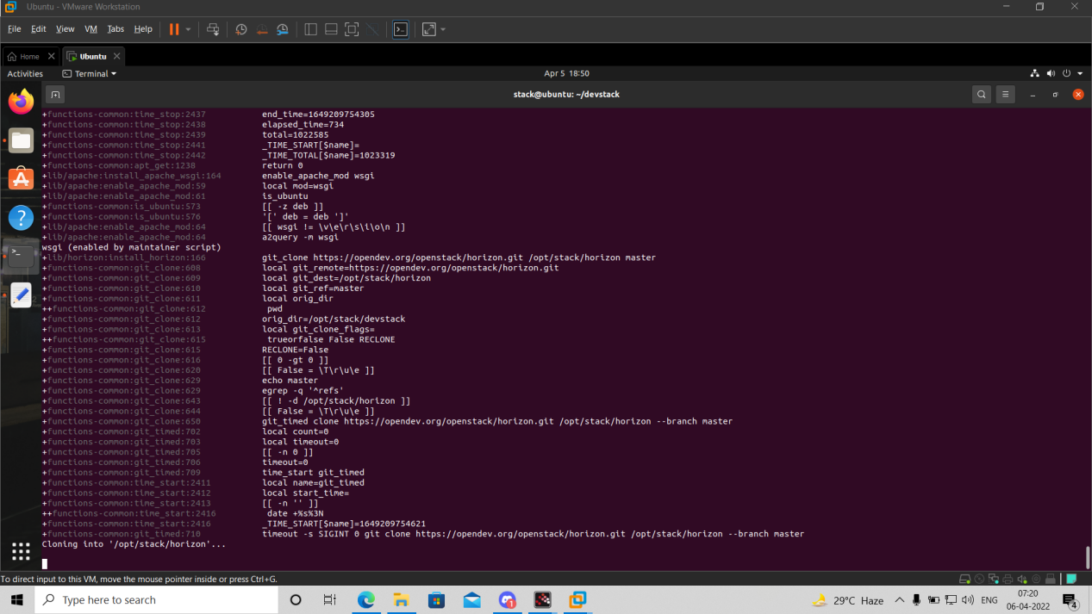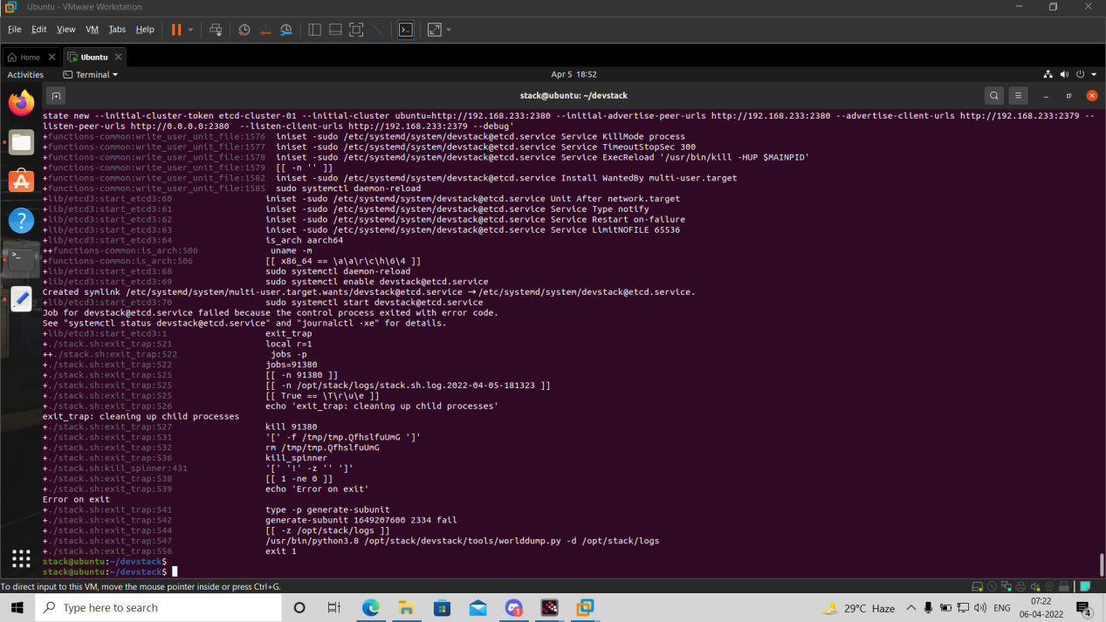

**Conclusion:** We have installed Ubuntu/Xen as bare metal hypervisor and implemented it. It provides access to computing resources in a virtual environment. With the help of Infrastructure as a service we can build our own IT platform. We can install Windows Operating System on Ubuntu and vice versa.

***Practical-04***

**Aim:** Study and implementation of Storage as a Service.

**Objectives:** From this experiment, the student will be able to •

. To make the students understand use of cloud as Platform, Storage as a services. •

. To learn the efficient tools to implement the technique

**Results:**

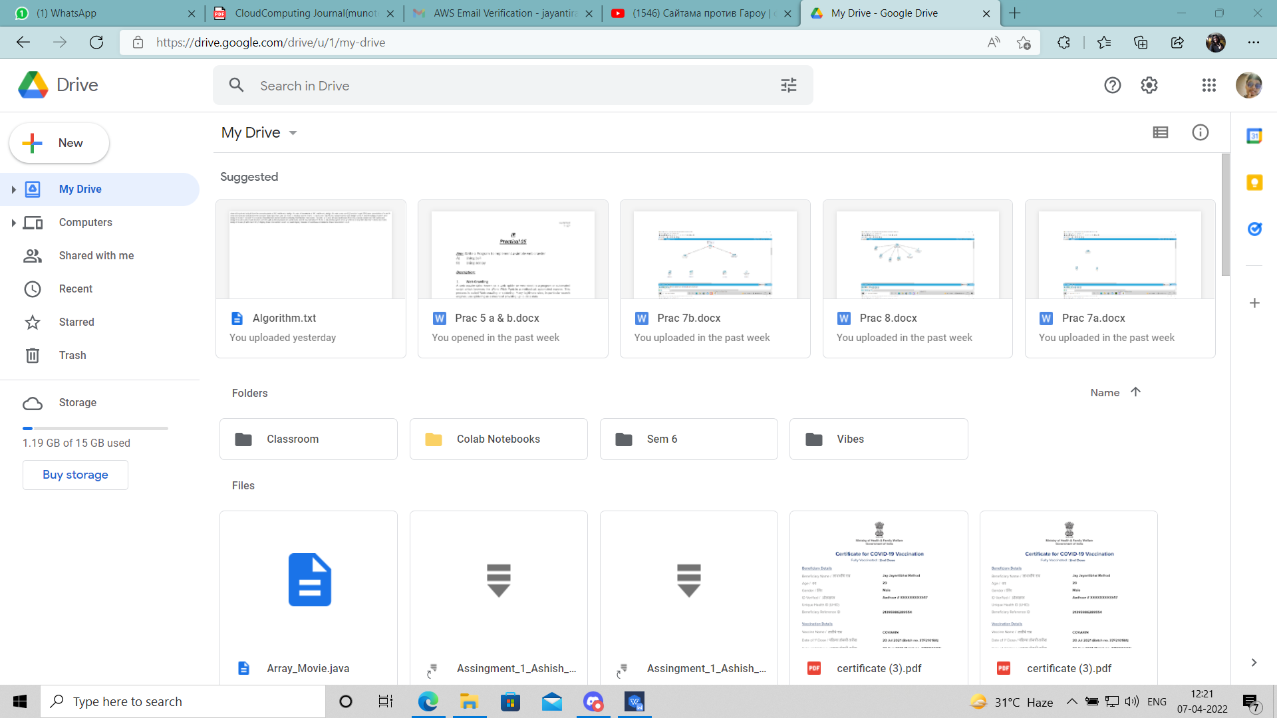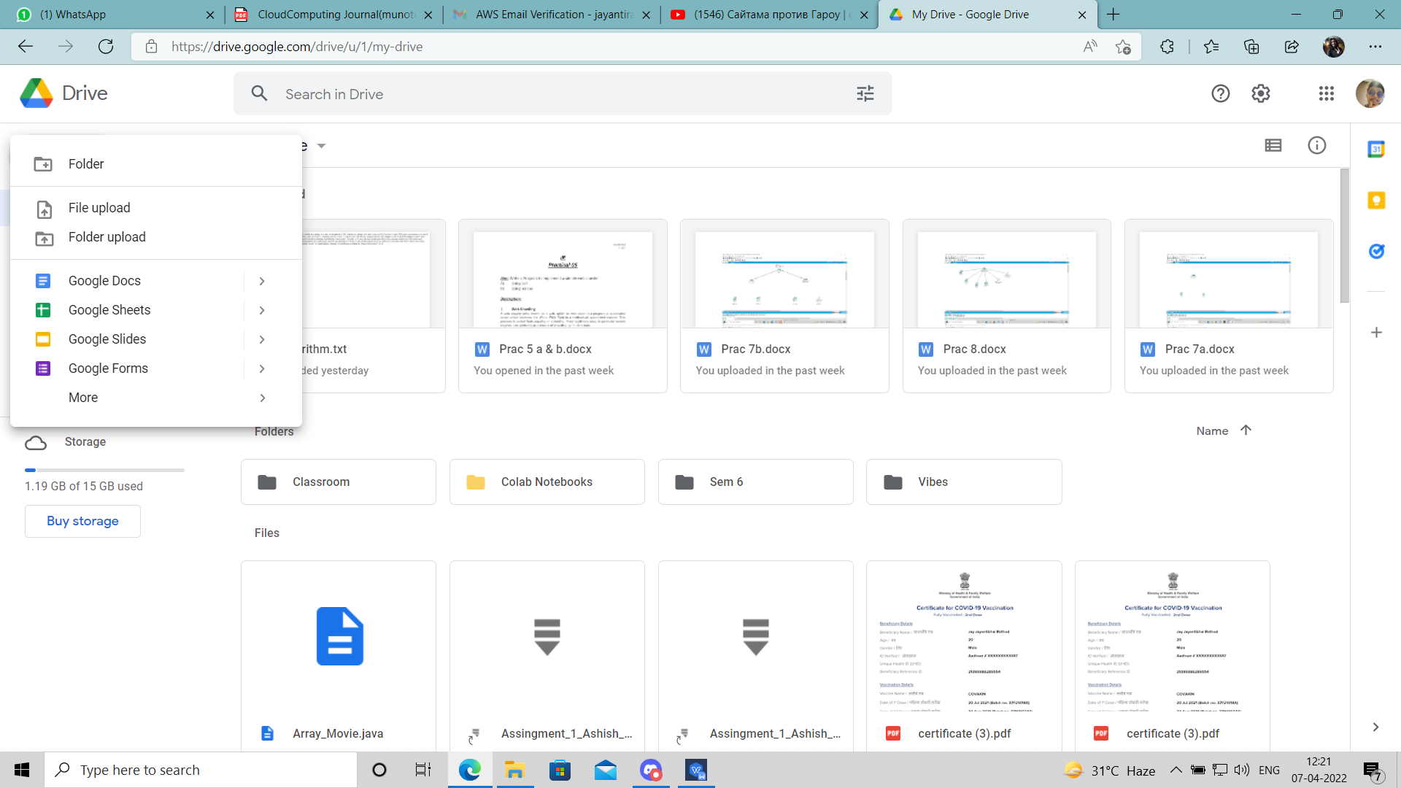

**Conclusion:** Google Docs provide an efficient way for storage of data. It fits well in Storage as a service (SaaS). It has varied options to create documents, presentations and also spreadsheets. It saves documents automatically after a few seconds and can be shared anywhere on the Internet at the click of a button.

***Practical-05***

**Aim:** Study and implementation of identity management

**Objectives:** From this experiment, the student will be able to,

. Understand concepts of virtualization and to use cloud as Infrastructure as a services. •

. Learn the technique and its complexity •

. Understand the importance of this technique from application point of view.

**Procedure:**

1. OwnCloud is open source file sync and share software for everyone from individuals operating the free ownCloud Server edition, to large enterprises and service providers operating the ownCloud Enterprise Subscription. ownCloud provides a safe, secure, and compliant file synchronization and sharing solution on servers that you control. You can share one or more files and folders on your computer, and synchronize them with your ownCloud server.
2. By default, the ownCloud Web interface opens to your Files page. You can add, remove, and share files, and make changes based on the access privileges set by you (if you are administering the server) or by your server administrator. You can access your ownCloud files with the ownCloud web interface and create, preview, edit, delete, share, and re-share files. Your ownCloud administrator has the option to disable these features, so if any of them are missing on your system ask your server administrator.
3. Apps Selection Menu: Located in the upper left corner, click the arrow to open a dropdown menu to navigate to your various available apps. Apps Information field: Located in the left sidebar, this provides filters and tasks associated with your selected app. Application View: The main central field in the ownCloud user interface. This field displays the contents or user features of your selected app.
4. Share the file or folder with a group or other users, and create public shares with hyperlinks. You can also see who you have shared with already, and revoke shares by clicking the trash can icon. If username auto-completion is enabled, when you start typing the user or group name ownCloud will automatically complete it for you. If your administrator has enabled email notifications, you can send an email notification of the new share from the sharing screen.
5. Five Share permissions are : Can share; allows the users you share with to re-share. Can edit; allows the users you share with to edit your shared files, and to collaborate using the Documents app. Create; allows the users you share with to create new files and add them to the share. Change; allows uploading a new version of a shared file and replacing it. Delete; allows the users you share with to delete shared files.

**Results:**

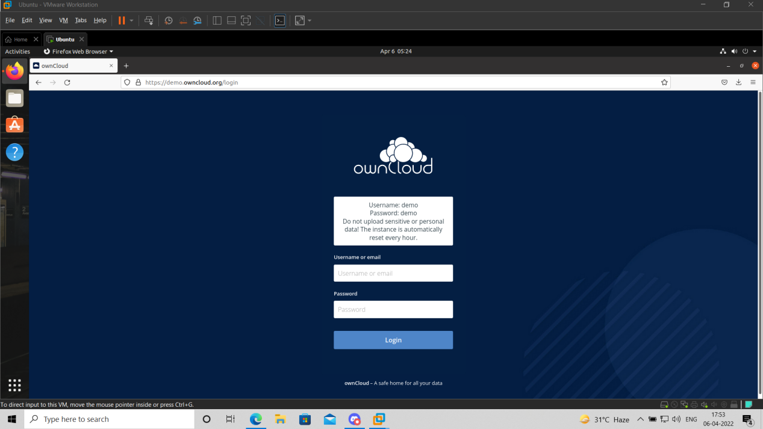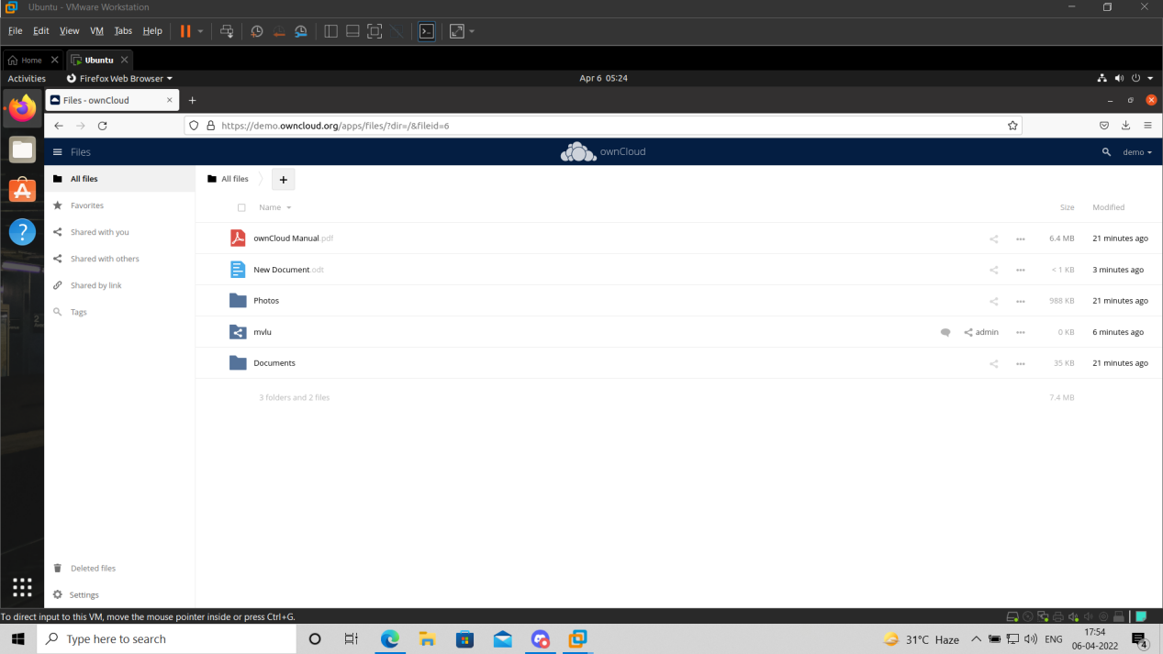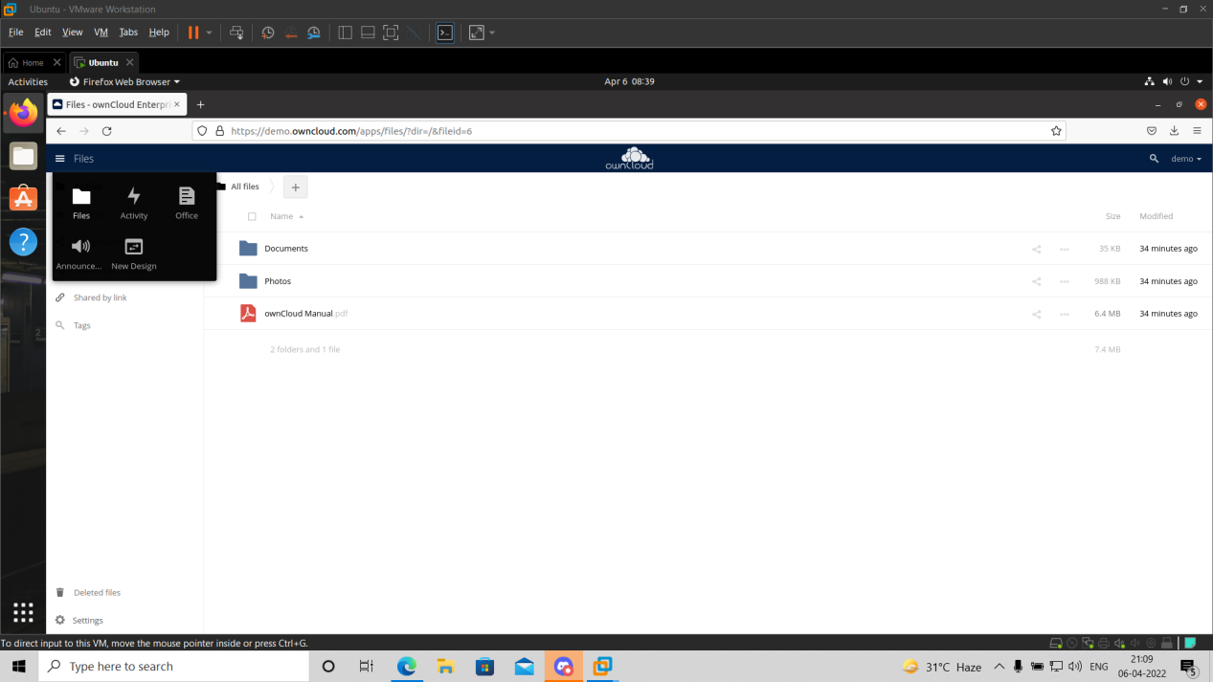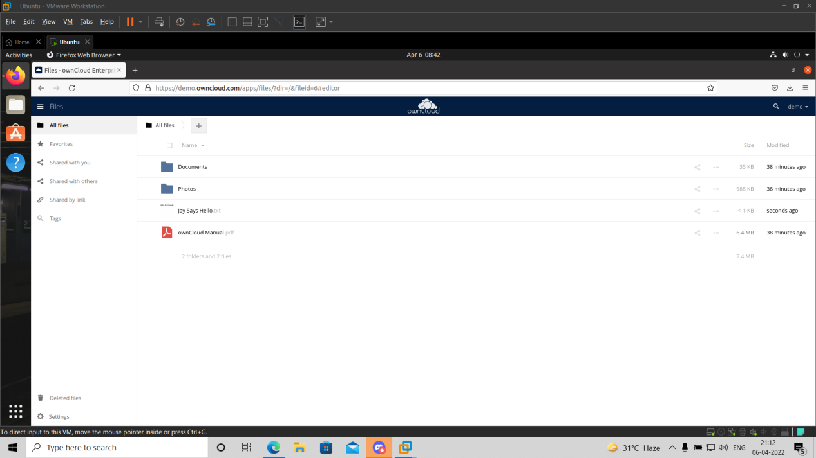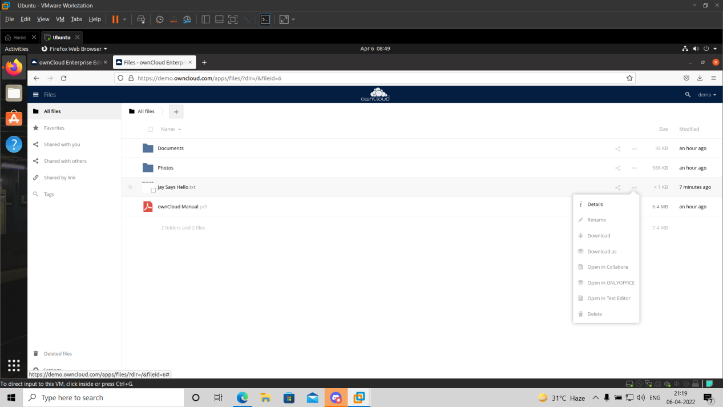

**Conclusion:** We have studied how to use ownCloud for ensuring identity management of the users. We can create multiple groups and provide privileges to view or modify data as per defined permissions. It also enables simplified look and feel to be used by anyone.

***Practical-06***

**Aim:** Study Cloud Security management.

**Objectives:** From this experiment, the student will be able, •

. To understand the security features of Cloud. •

. To learn the technique of application security management and its complexity •

. To understand the importance of cloud security management from application point of view.

**Outcomes:** The learner will be able to •

. Student can study and implement single-sign-on. •

. To use current techniques, skills, and tools necessary for computing practice. •

. To match the industry requirements in the domains of Database management, Programming and Networking with the required management skills.

**Theory:**Cloud computing security is the set of control-based technologies and policies designed to adhere to regulatory compliance rules and protect information, data applications and infrastructure associated with cloud computing use. Because of the cloud's very nature as a shared resource, identity management, privacy and access control are of particular concern. With more organizations using cloud computing and associated cloud providers for data operations, proper security in these and other potentially vulnerable areas have become a priority for organizations contracting with a cloud computing provider. Cloud computing security processes should address the security controls the cloud provider will incorporate to maintain the customer's data security, privacy and compliance with necessary regulations. The processes will also likely include a business continuity and databackup plan in the case of a cloud security breach. Physical security Cloud service providers physically secure the IT hardware (servers, routers, cables etc.) against unauthorized access, interference, theft, fires, floods etc. and ensure that essential supplies (such as electricity) are sufficiently robust to minimize the possibility of disruption. This is normally achieved by serving cloud applications from 'world-class' (i.e. professionally specified, designed, constructed, managed, monitored and maintained) data centers. Personnel security Various information security concerns relating to the IT and other professionals associated with cloud services are typically handled through pre-, para- and post-employment activities such as security screening potential recruits, security awareness and training programs, proactive security monitoring and supervision, disciplinary procedures and contractual obligations embedded in employment contracts, service level agreements, codes of conduct, policies etc. Application security Cloud providers ensure that applications available as a service via the cloud (SaaS) are secure by specifying, designing, implementing, testing and maintaining appropriate application security measures in the production environment. Note that - as with any commercial software - the controls they implement may not necessarily fully mitigate all the risks they have identified, and that they may not necessarily have identified all the risks that are of concern to customers. Consequently, customers may also need to assure themselves that cloud applications are adequately secured for their specific purposes, including their compliance obligations.

**Hardware/Software Requirements:** Ubuntu operating system, Virtual machine, WAMP/ZAMP server, Any tool or technology can be used for implementation of web application e.g., JAVA, PHP, etc.

**Procedures:** Security using MFA(Multi Factor Authentication) device code: 1) goto aws.amazon.com 2) click on "My Account" 3) select "AWS management console" and click on it 4) Give Email id in the required field if you are registering first time then select "I am a new user" radio button 5) click on "sign in using our secure server" button 6) follow the instruction and complete the formalities (Note: do not provide any credit card details or bank details) sign out from 7) Again go to "My Account" select "AWS management console" and click on it Sign in again by entering the user name and valid password ( check "I am returning user and my password is" radio button) Now you are logged in as a Root User All AWS project can be viewed by you, but you cant make any changes in it or you cant create new thing as you are not paying any charges to amazon (for reason refer step:6) To create the user in a root user follow the steps mentioned below: 1) click on "Identity and Access Management" in security and identity project 2) click in "Users" from dashboard It will take you to "Create New Users" click on create new user button enter the "User Name" (select "Generate and access key for each user" checkbox, it will create a user with a specific key) click on "Create" button at right bottom 3) once the user is created click on it 4) go to security credentials tab 5) click on "Create Access Key", it will create an access key for user. 6) click on "Manage MFA device" it will give you one QR code displayed on the screen you need to scan that QR code on your mobile phone using barcode scanner (install it in mobile phone)you also need to install "Google Authenticator" in your mobile phone to generate the MFA code 7) Google authenticator will keep on generating a new MFA code after every 60 seconds that code you will have to enter while logging as a user. Hence, the security is maintained by MFA device code... one can not use your AWS account even if it may have your user name and password, because MFA code is on your MFA device (mobiel phone in this case) and it is getting changed after every 60 seconds. Permissions in user account: After creating the user by following above mentioned steps; you can give certain permissions to specific user 1) click on created user 2) goto "Permissions" tab 3) click on "Attach Policy" button 4) select the needed policy from given list and click on apply.

**Results:**

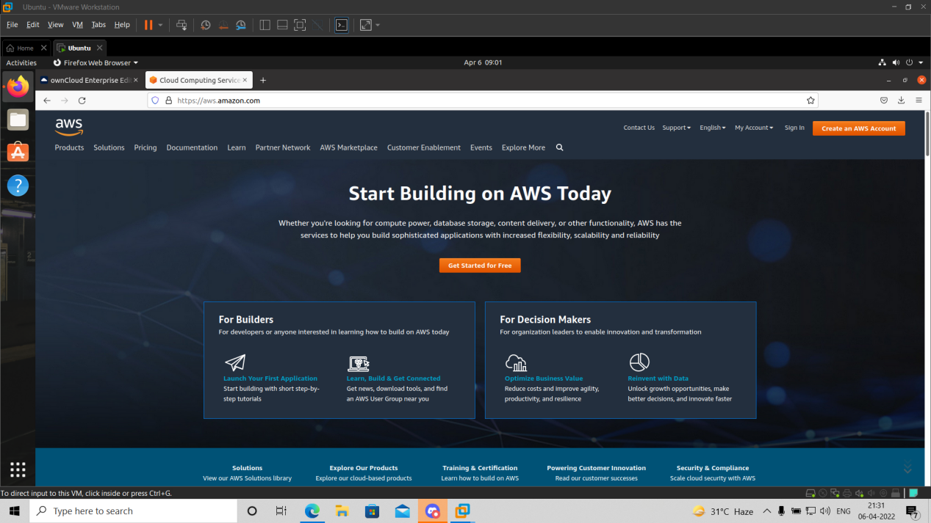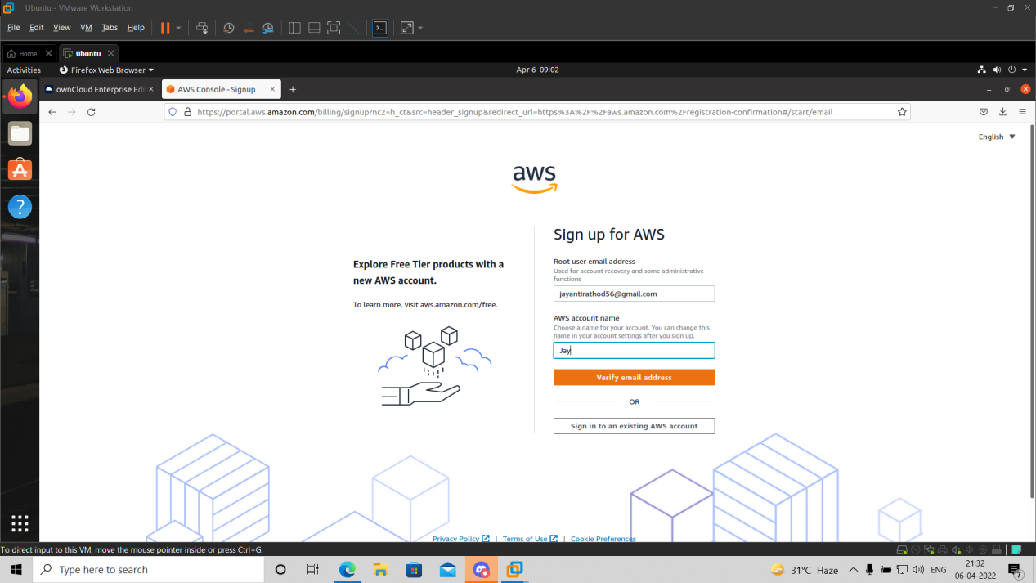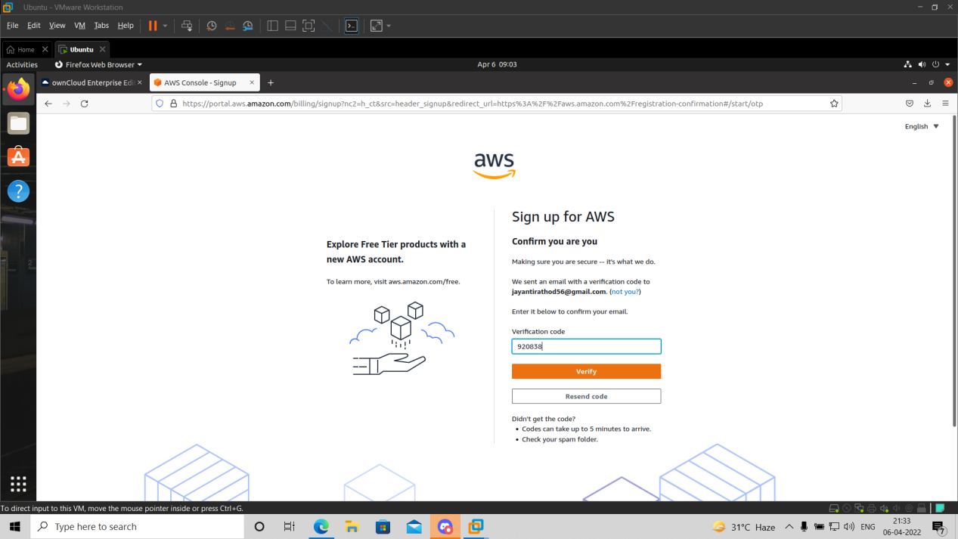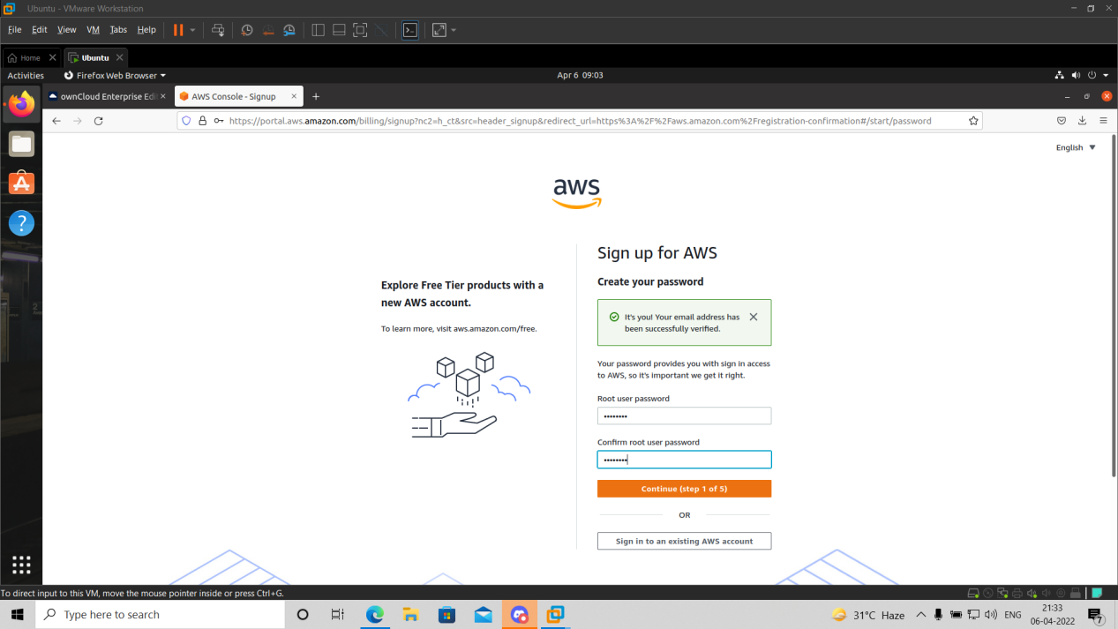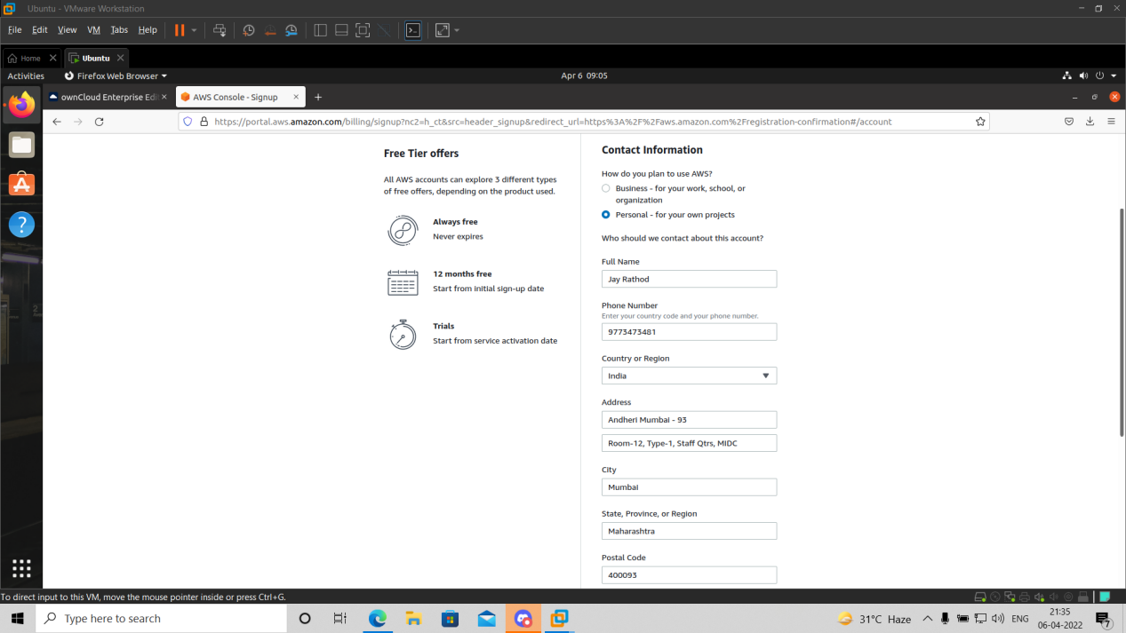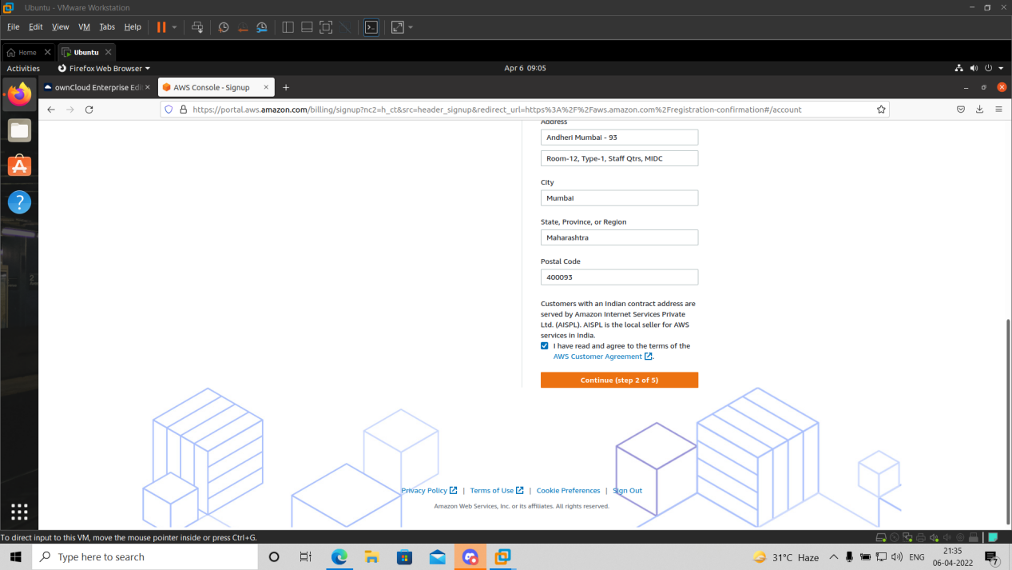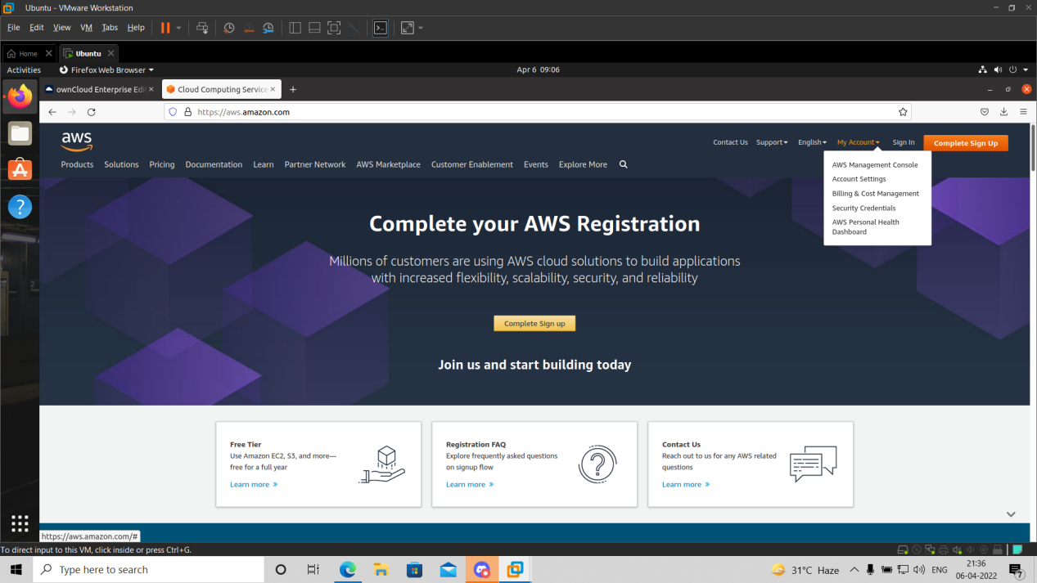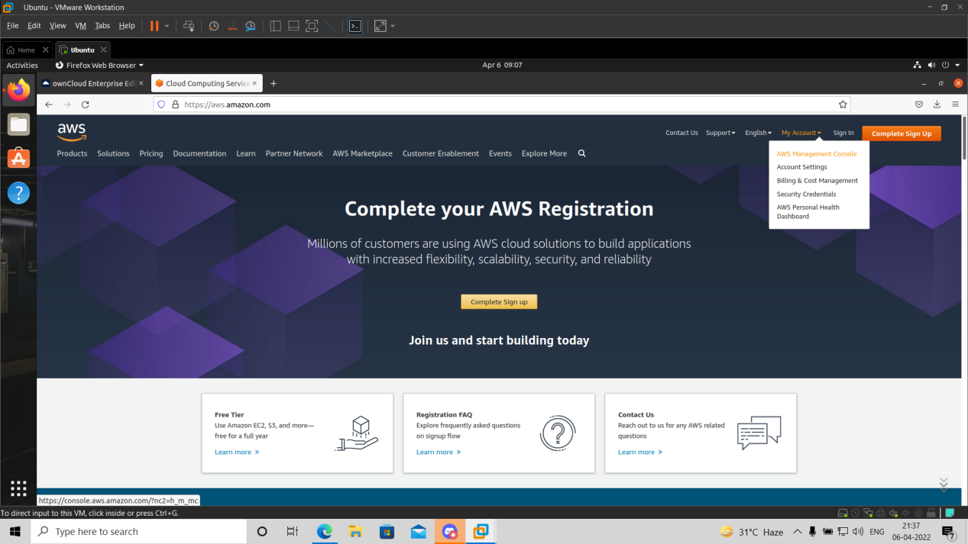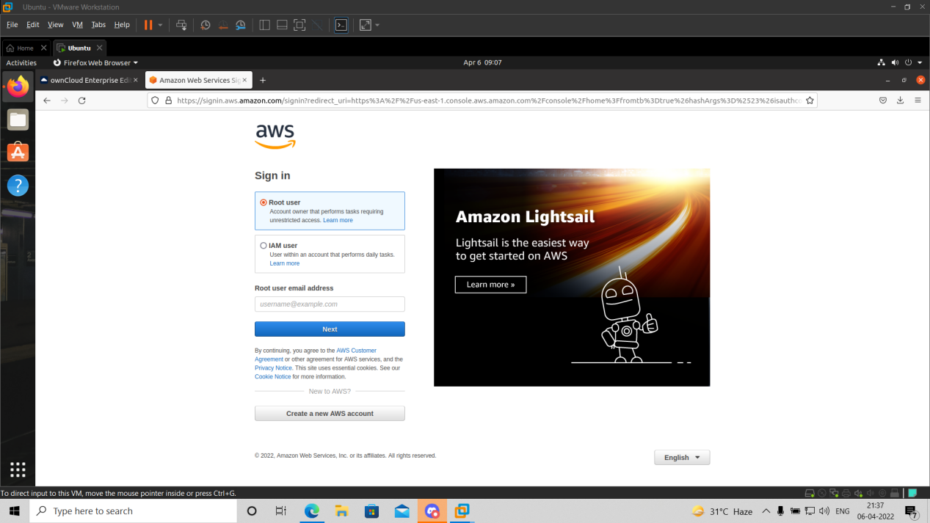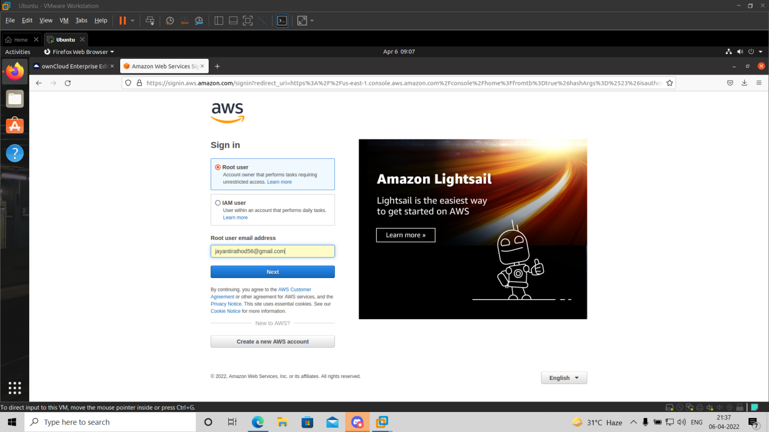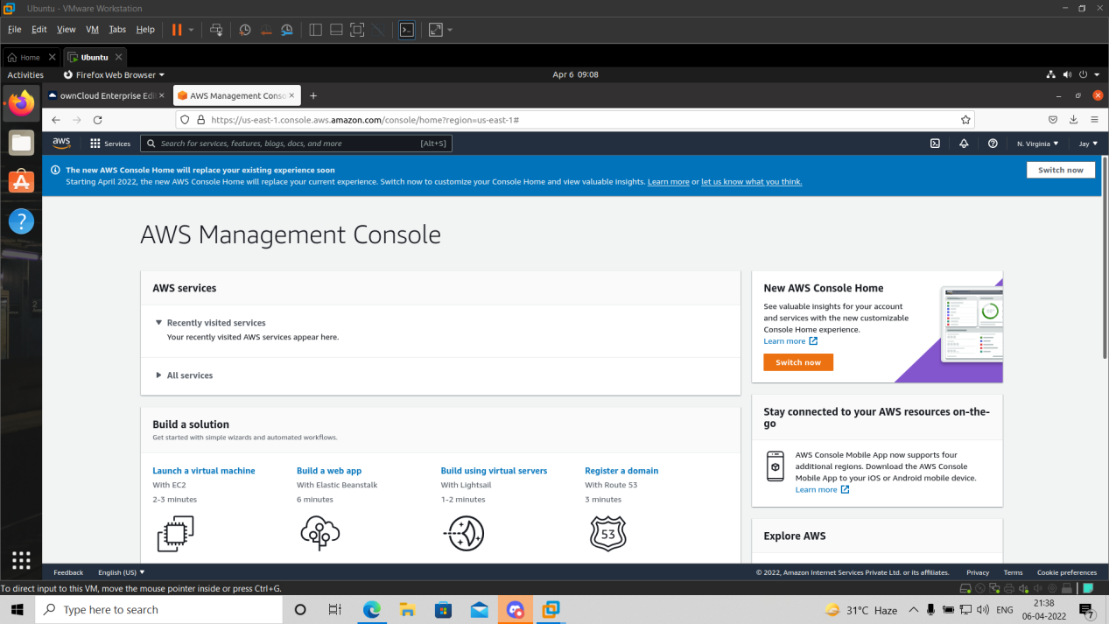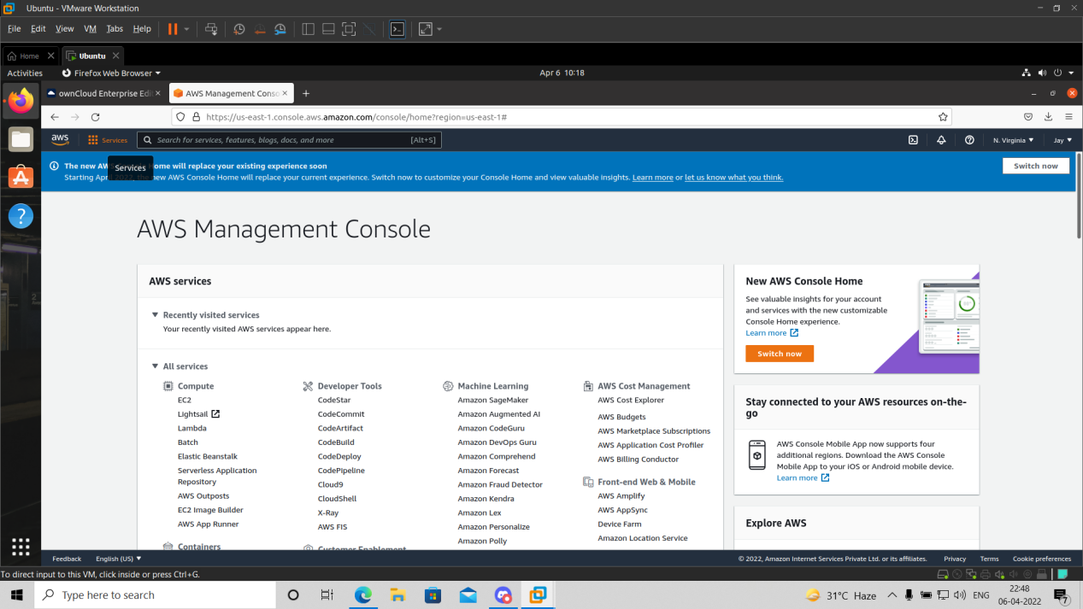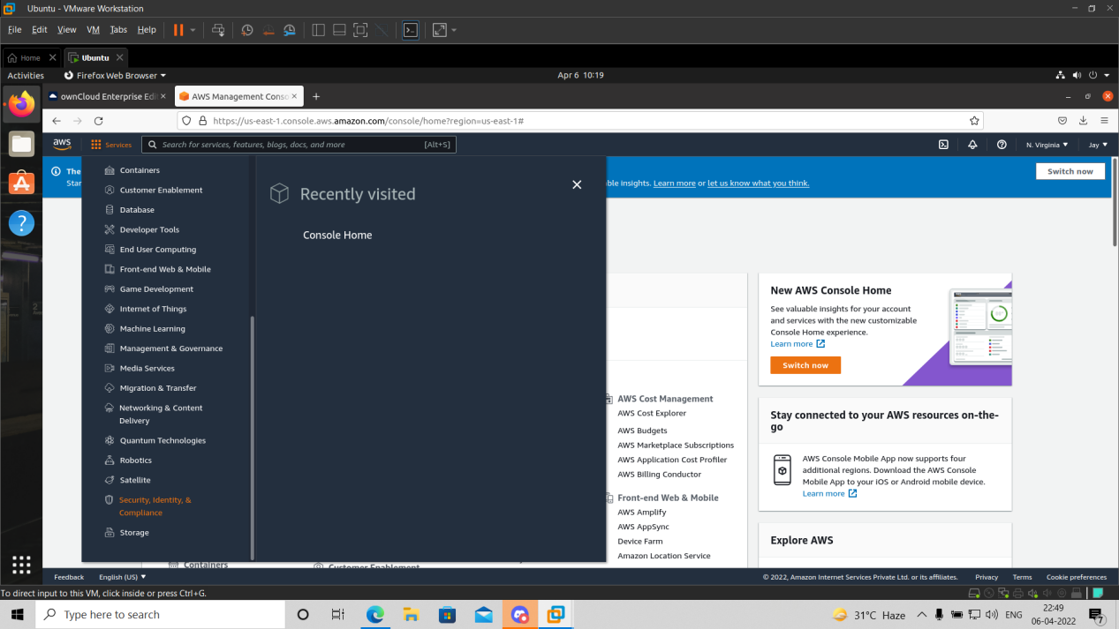

**Conclusion:** We have studied how to secure the cloud and its data. Amazon EWS provides the best security with its extended facilities and services like MFA device. It also gives you the ability to add your own permissions and policies for securing data more encrypted.

***Practical-07***

**Aim:** Write a program for web feed.

RSS - Really Simple Syndication Concept:

Web feed and RSS Objective:

this lab is to understand the concept of form and control validation

Scope:

Write a program for web feed Technology: XML / PHP, HTML

https://www.w3schools.in/php/php-rss-feed/ RSS technology is used by millions of users around the world to get the latest information from their favorite websites. https://www.xul.fr/en-xml-rss.html Building and Using an RSS Feed

***Practical-08***

**Aim:** Study and implementation of Single-Sing-On.

Title: Study and implementation of Single-Sing-On.

Concept: Single Sing On (SSO),openID

Objective: is to understand the concept of access control in cloud and single sing on (SSO), Use SSO and advantages of it, and also students should able to implementation of it.

Scope: installing and using JOSSO

Technology: JOSSO

***Practical-09***

**Aim:** User Management in Cloud.

Concept: Administrative features of Cloud Managenet ,User Management Objective: is to understand how to create, manage user and group of users accounts. Scope: Installing and using Administrative features of ownCloud Technology: ownCloud

***Practical-10***

**Aim:** Case study on Amazon EC2/Microsoft Azure/Google Cloud Platform.

**Results:**

